**Essential Logistics KPIs and Metrics Part 1**

These 18 logistics metrics can help your business manage costs and improve customer satisfaction. These costs relate to shipping, distribution, transportation, warehousing and logistics performance. Use these KPIs to identify problems and optimize your processes.

**Formulas for Transportation KPIs**

* **Average Cost per Order:** The average cost per skid or order is a combination of all the hidden and more obvious costs. The metric compares the number of skids or orders to the total cost of the shipment or effort. This measurement can help to identify skids or orders whose costs are unusually high.

|  |  |
| --- | --- |
| **AVERAGE COST PER ORDER EXAMPLE**  **St. Peter Hardware** | |
| **Marketing campaign** | **P 500** |
| **COGS** | **1,200** |
| **Packaging** | **50** |
| **Shipping costs** | **200** |
| **Storage costs** | **100** |
| **Number of orders** | **300** |

**Use Excel in Solving:**

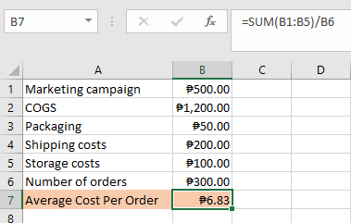

In St. Peter Hardware scenario, the average cost per order is P6.83.

* **Average Transportation Cost:** The average transportation cost is the average cost of transportation expenses compared to gross monthly income. This measures the distribution of the expenses from order placement to delivery. This includes actual transit costs and those for order processing, which is a small percentage of administration, inventory carrying and warehousing.

**Average Transport Cost Example:** A company has an P800 average monthly transportation cost and P10,000 monthly gross income

**Use Excel in Solving:**

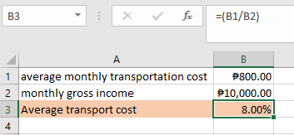

This company spends about 8% of its monthly income on transportation.

* **Freight Cost per Unit Shipped:** Freight cost per unit shipped is the total freight costs divided by the number of units shipped in the period. The measurement considers things like cargo mix and making sure the container is not underloaded. Companies want full container loads.

**Freight Cost per Unit Shipped Example:** P4,200 for 6,000 units

**Use Excel in Solving:**

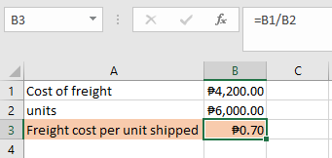

In this example, the freight was P.70 per unit in shipping.

**Formulas for Supply KPIs**

* **Transit Time to Distance:** The transit time to distance compares the distance a shipment travels to the time it takes it to go from pickup to destination.

Transit Time to Distance Example: 5 days, 2,000 miles

**Use Excel in Solving:**

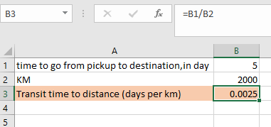

In this example, the travel time to distance is 0.0025 days per km.

* **Stock Rotation:** Stock rotation, also known as inventory turnover, is the number of times a company sells its inventory in a period. This metric helps companies monitor aging stock.

**Stock Rotation Example:** St, Peter Hardware has P10,000 in sales and P5,000 in average inventory.

**Use Excel in Solving:**

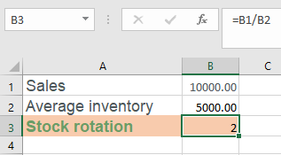

In this scenario, St, Peter Hardware sells through its stock 2 times in this period.

* **Out-of-Network Shipment:** Out-of-network shipments are the unusual shipments ordered due to stock depletion. These shipments can be expensive. The ratio of out-of-network shipments compares them to total shipments.

**Out of Network Shipment Example:** There are 20 out-of-network shipments out of the 5,450 shipments in this period.

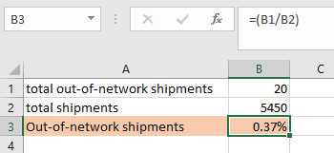

In this situation, 0.37% of shipments in this period were out-of-network.

**Examples of Distribution KPIs**

* **On-Time Final Delivery:** On-time final delivery, also known as on-time delivery (OTD), is the ratio of products delivered on-time to customers compared to the total number of shipped products. The KPI measures supply chain efficiency and performance in delivery operations. The units shipped on-time is for the whole order, not broken down by piece.

**On-Time Final Delivery Example:** Of the 18 orders delivered this week, 15 were delivered in full, two partial deliveries and one order pending.

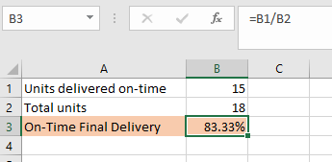

In this scenario, the company delivered 83% of products on-time. The goal of OTD is always 100%.

* **On-Time Pickup:** On-time pickup is the number of pickups the freight carrier made on-time compared to the period's total shipments. This metric shows carrier performance, which boosts customer satisfaction and shipping efficiency. Experts recommend relying on documentation transit time, not on the carrier's data.

**On-Time Pickup Example:** This month, St. Peter Hardware picked up 43 shipments on time out of a total of 46 shipments.

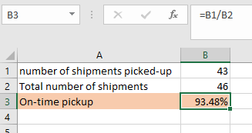

In this example, the on-time pickup performance was 93.5%. Experts consider anything above 90% acceptable.

* **On-Time Shipping:** On-time shipping is how close the carrier came to shipping out the order when promised. Measure the number of units shipped out on time compared to the number of units shipped during that period. Orders must be in-full to count toward this metric.

**On-Time Shipping Example:** Of the 23 orders shipped out on-time, 18 were in-full and on-time, three were partial orders shipped on-time and two were behind what the company promised.

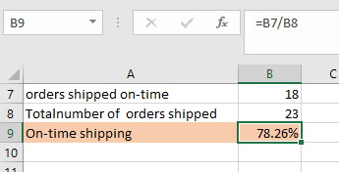

Using these numbers, the company shipped 78.3% of orders out on-time. The goal is always 100%.

**Essential Logistics KPIs and Metrics Part 2**

**Formulas for Warehouse and Order Management KPIs**

* **Unplanned Shipment:** The unplanned shipment, also known as the unplanned supply order lines, are the number of supply order lines not being shipped soon. The company has no plans to ship these products. This metric is the number of unplanned shipments compared to the total number of shipments.

**Unplanned Shipment Example:** Four unplanned shipments this month; 4,000 shipments completed this month

**Unplanned shipment =** (number of unplanned shipments) **/** (number of total shipments) **×** 100  
**Unplanned shipment =** 4 **/** 4,000 **×** 100  
**Unplanned shipment =** 0.1%

In this example, this company has 0.1% of its shipments in unplanned shipment status.

* **Order Accuracy:** Order accuracy, also known as order picking accuracy, is the number of orders picked and verified as accurate compared to the total number of orders picked for a period. This metric helps with process improvement in the warehouse.

**Order Accuracy Example:** Quality control verified 123 orders correct from the 128 picked today.

**Order accuracy =** (# order verified correct) **/** (# orders picked today) **×** 100  
**Order accuracy =** 123 **/** 128 **×** 100  
**Order accuracy =** 96%

In this scenario, quality control staff verified that 96% of today's picks as accurate. Since this metric affects customer satisfaction, companies should work to make it as high as possible.

* **Inventory Accuracy:** The inventory accuracy KPI is the accuracy of inventory in stock compared to what the database shows are in stock. This metrics shows the effectiveness of your bookkeeping methods and ensures there are no stockouts.

**Inventory Accuracy Example:** There are 3,458 items counted in stock; the system lists 3,506 items.

**Inventory accuracy =** (# items counted) **/** (# items system lists as present) **×** 100  
**Inventory accuracy =** 3,458 **/** 3,506 **×** 100  
**Inventory accuracy =** 98.6%

This example shows that 98.6% of items are accurately in-stock. The metric does not differentiate between entities, just the number of overall items.

* **Dock-to-Stock:** Dock-to-stock cycle time is how long it takes for a product to go from the start of its receipt to when it is put away and ready for sale compared to the total number of shipments received. Staff usually count this in hours.

**Dock-to-Stock Example:** 12 hours and 18 shipments

**Dock to stock =** (# hours for received product to be put away) **/** (# shipments)  
**Dock to stock =** (12 hours **/** 18 shipments)  
**Dock to stock =** 0.67 hours per shipment

The equation shows that the dock-to-stock cycle time for this company is 0.67 hours per shipment.

* **Units Processed per Square Foot:** Units processed per square foot, also known as productivity in transferred volume, are distribution metrics that compare the number of units or goods processed to usable warehouse space.

**Units Processed per Square Foot Example:** 60,000 units and 16,400 square feet of usable area.

**Units processed per square foot =** (# units processed) **/** (useable space)  
**Units processed per square foot =** 60,000 units **/** 16,400 square feet  
**Units processed per square foot =** 3.7 units/ft2

In this situation, there are 3.7 units/ft2, taking up a fair amount of usable warehouse space.

* **Space Use in Warehouse:** Space use in warehouse, also known as space utilization, is the percent of bins used. This metric ensures optimal use of warehouse space. Calculate this metric by comparing the amount of warehouse space used by what is available.

**Space Use in Warehouse Example:** 3,300 feet square used in a 16,500-foot square warehouse

**Space used in warehouse =** (warehouse space with product) **/** (total warehouse space) **×** 100  
**Space used in warehouse =** 3,300 ft2 **/** 16,500 ft2 **×** 100  
**Space used in warehouse =** 20%

In this example, 20% of the warehouse space is filled with product, which is average for warehouses.

**Formulas for Logistics Performance Metrics**

* **Cost per Pound:** Cost per pound is the cost of a shipment compared to its weight in pounds. Use this measure to compare carriers, weekly invoices and individual shipments.

**Cost per Pound Example:** $836.24 for a shipment of 2,200 lbs.

**Cost per pound =** (Cost of shipment) **/** (Weight of shipment)  
**Cost per pound =** $836.24 **/** 2,200  
**Cost per pound =** $0.38

In this situation, the cost per pound is $0.38. This result is typical; the most frequent ranges are $0.22–$0.42. A per-pound fee anywhere between $0.06 and $0.75 is not unusual.

* **Cost per Mile:** Cost per mile calculates the profit distribution for a load. Marketing also uses this metric for campaigns. However, in distribution, the measurement is the total monthly expenses or total load cost compared to the number of miles driven. The prices are fixed and variable.

**Cost per Mile Example:** $2,540 variable costs, $2,312 fixed costs and 3,600 monthly miles

**Cost per mile =** (Total fixed and variable costs) **/** (Monthly miles)  
**Cost per mile =** ($2,540 **+** $2,312) **/** (3,600 miles)  
**Cost per mile =** $1.34 per mile

In this example, if the mileage stays at 3,600 miles per month, spending $1.34 per mile will meet expenses.

* **Number of Shipments:** The number of shipments is a straightforward metric representing the monthly count of how many shipments a company sends. Companies can break this down by region, country or product type. The totals will show the seasonal fluctuations and help companies prepare and allocate resources over the year.

**Number of Shipments Example:** 200 shipments added up for the month.  
Monthly shipment, by region:  
Eastern region: 120  
Western region: 40  
Southern region: 40

Monthly shipment, by product type:  
Information widgets: 12,040  
Control widgets: 2,440  
Hybrid widgets: 1,832  
Collection widgets: 10,030

In this scenario, we broke down the loads by region and product. For example, 120 shipments of four different products, totaling 26,342 items, went to the eastern region last month.

**KPI Do's**

* Prioritize processes and operations.
* Make your KPIs relevant.
* Choose simple, attainable KPIs. Simple measures lead to targeted fixes.
* Consider the performance elements of your chosen metrics.
* Focus on the activities that help staff perform better.

**KPI Don'ts**

* Do not make up new standards. Learn about your industry KPIs and focus on them first.
* Do not develop measures without getting buy-in from staff.
* Do not make your KPIs intangible. Regularly review them and make adjustments.
* Do not make your KPIs static. Raise the benchmarks once you meet or exceed them.
* Do not shoot for merely meeting minimums for all KPIs. Instead, strive to reach the minimum acceptable performance levels.